**Name: Kaung Myat Noe**

**Address:** No.(446), Strand road, corner of 54th street, Botahtaung,

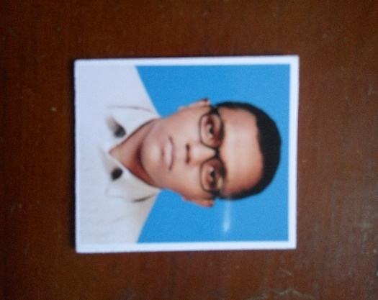 3rd floor.

**Nationality:** Myanmar

**Language known:** Myanmar, English

**Gender:** Male

**Date of Birth:** 19, April, 1999

**Tel:** 09 – 450032533, +959785441834

**Email:** [obamese.969@gmail.com](mailto:obamese.969@gmail.com)

**Curriculum Vitae**

**Objectives**

* To work in an organization where culture of freedom and working for initiative in ensured, facilitating my contribution through and action to the company’s vision and thus achieve self-development by playing a significant role in building the organization.
* To work with maximum potential in a challenging and dynamic environment, with an opportunity of working with diverse group of people and enchancing my professional skills with learning and experience for career growth.

**Academic Qualification:** Post-Graduate Qualifications

**Education**

**2014-2015:** Finished High school (Botahtaung(5)).

**2015-2016:** practical A+ andsoftware intermediate.

**2015-2016:** English specialized for teaching.

**2015-2017:** GUSTO Higher Education Institute (Diploma) (Qualified).

**Skills**

**Language:** Apart from mother language

English (Fluent)

Japanese (N5 level)

**Hardware:** Able to fix problems in HDD, mouse, keyboard and some small problems

**Software:** worked as an junior developer [Java(1 year), C#(4 months), ASP.Net(1

year), web developer {HTML, CSS, Javascript}(6 months), Database

developer (1 year)], Xamarin (1 year), Angular (1 year).

**Professional Appointments**

**Projects:** Java (2 projects)

C# (1 project)

ASP.Net (2 projects)

Website (2 projects)

Database design (3 projects)

Android Development [Xamarin] (4 projects)

Angular 6 (6 projects)

API (10 projects)

**Company:**

* Global Wave technology (7 months and so on..)

Date: 2018 June - 2019

**Position:** Software Developer

**Responsibility:** Full responsibility for the whole project until it’s final release. Updates and bug fixes.

**Work Experience**

**Training courses:** ISO 27001 (Qualified)

**Workshops:** Globalwave Technology OJT (Qualified)

**Conferences:** Barcamp (2019, 2018, 2017) (Attended)

**Teaching Profiles:** Trained co-workers (programming) (A+) (Networking) and others.

**Awards and achievements:** ISO 27001 certified.

----------------------------------------------------------------------------------------

**Leadership:** Can make plans, divide and assign those into respective members. Can Work under high pressure.

**Communication:** Excellent in communication

**Problem solving:** Expert level. Had to deal with daily life problems and stuffs.

**Operating System:** Window 7,8,8.1,10

**Backup and restore:** Window Backup, Symantec backup, manual backups

**Antivirus:** Malware, antivirus, McAfee, Norton Antivirus, Symantec antivirus

**IDE:** Edraw, Java IDE, SQL server 2015, 2017, Arduino 8.1, Visual Studio all series.

**Application Package:** MS Office, Adobe Photoshop, PageMaker, Pathloss, Google Earth.

**Personal**

**Date of birth**: 19.4.1999

**Nationality:** Myanmar

**National Identity card:** 12/BTH(N)042108

**Marital status:** Single

**Personal interest:** Engineering, It/Computer (Especially hardware), learning language, Learning English, Inventing things.

**Other Qualification:**

* (Practical A+) course from KMD
* (Software Intermediate) course from KMD
* Completed four skills, pre-intermediate, intermediate from SUCCESS language Academy
* Japanese language (N4 level) from METRO Institute

**Apply Position:**

* Any position related to Software development
* I would like to apply any position that are related to my specialized fields of study that I mentioned above